**PROPERTY ANALYSIS BI DEVELOPER- STANDARD SPRINT - PART 3-BUILD SSRS REPORT**

**Task-15 : Given suburb and city, display median rental value, median yearly income, and value changes of the property within 1 km radius**

**STORED PROCEDURE**

**SSRS REPORT SAMPLE OUTPUT:**

**Task-16: Given suburb and city, display local public transport within 1km radius - update data sets**

**STORED PROCEDURE:**

**SSRS REPORT DESIGN:**

**SSRS REPORT SAMPLE OUTPUT:**

**Task-17: Given suburb and city, display local schools within 1km radius**

**STORED PROCEDURE**

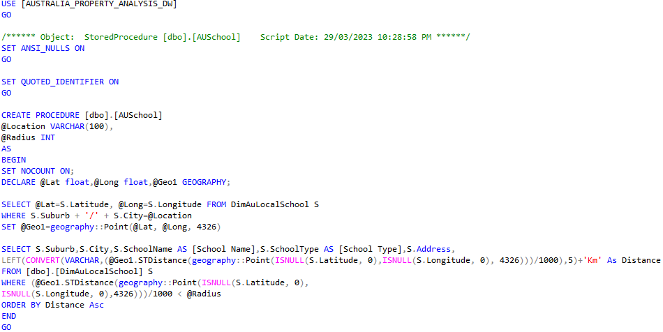

**SSRS REPORT SAMPLE OUTPUT:**

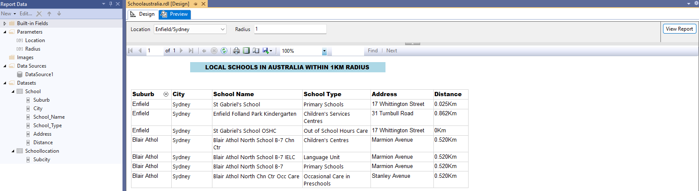**Task 18: Given suburb and city, display crime rate within 1 km radius**

**STORED PROCEDURE**

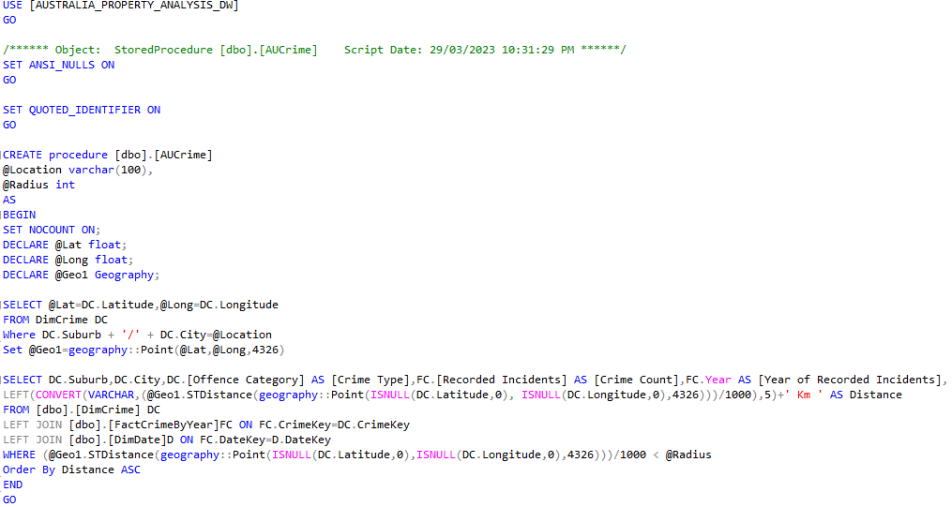

**SSRS REPORT DESIGN:**

**SSRS REPORT SAMPLE OUTPUT:**

**Task-19: Given suburb and city, display property value of the area in Column chart and line chart of 1 year, 5 years and 10 years value**

**STORED PROCEDURE 1**

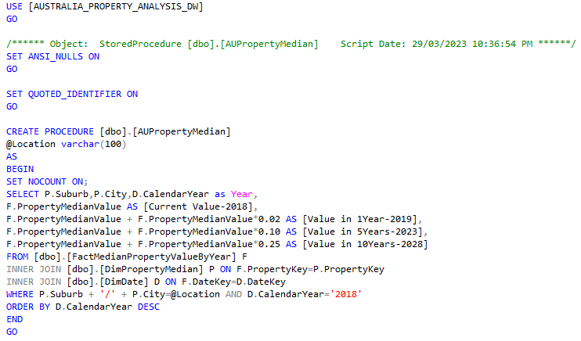

**SSRS REPORT DESIGN :**

**STORED PROCEDURE 2-UNPIVOT**

**SSRS REPORT SAMPLE OUTPUT:**

